Low-level widgets

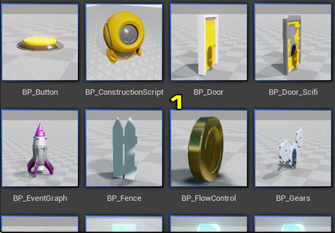

High-level widgets

